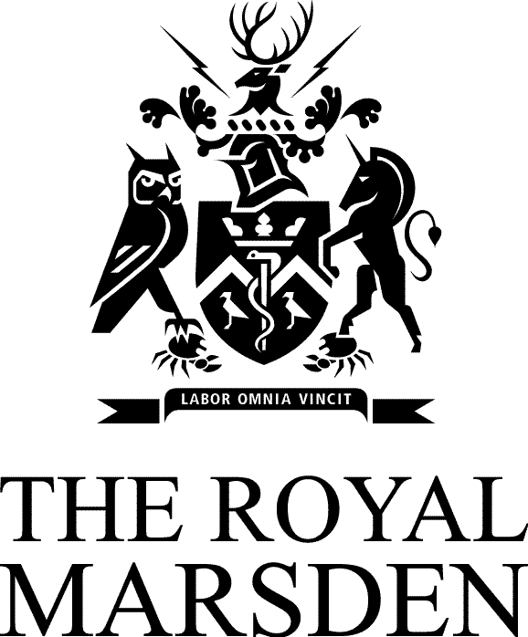
Teenagers and Young Adults with Cancer

Monday 29th July 2013
Time: 09.00-15.45

Programme
Educational Events

09.00 | Registration and Coffee
09.45 | Setting the scene Louise Soanes, Nurse Consultant for Adolescents and Young Adults, The Royal Marsden NHS Foundation Trust
10.00 | Teenagers and young adults (TYA), their physical & psychological development and how they fit into society  Sarah Houghton, CLIC/Sargent Social Worker for Young People, The Royal Marsden NHS Foundation Trust
10.30 | Teenagers and young adults and cancer: treatment and service needs  Louise Soanes, Nurse Consultant for Adolescents and Young Adults, The Royal Marsden NHS Foundation Trust
11.00 | Coffee
11.30 | Recognising and managing distress and anxiety in teenagers and young adults with cancer  Dr Lesley Edwards, Consultant Clinical Psychologist, The Royal Marsden NHS Foundation Trust
12.00 | Promoting self management of symptoms (e.g. ASyms-Yg stage IV)  Dr Faith Gibson, Senior Lecturer/Rachel Taylor, Researcher  Patient Care Research and Innovation Centre, Institute of Child Health, London
12.30 | Supporting the families of teenagers and young adults with cancer  Sue Morgan MBE, Nurse Consultant for Teenagers and Young Adults, St James’s Hospital, Leeds
13.00 | Lunch
14.00 | Teenagers and young adults’ access to health care and delayed diagnosis  Dr Susie Pearce, UCLH, London
14.30 | Managing palliative and end of life care in teenagers and young adults with cancer – a case study  Maggie Breen, McMillan CNS , CYP Symptom Care and Oncology Outreach, The Royal Marsden NHS Foundation Trust & Bev Barclay
15.00 | Survivorship – what does it mean for teenagers and young adults  Dr Anne Grinyer, Senior Lecturer in Health Research, Lancaster University
15.30 | Conclusion and the way forward  Louise Soanes, Nurse Consultant for Adolescents and Young Adults, The Royal Marsden NHS Foundation Trust
15.45 | Close
Venue: National Heart and Lung Institute, Guy Scadding Building, Dovehouse Street,
London SW3 6LY

Cost of the Day: The cost of this day is £95.00 per attendee. This includes lunch and coffee/tea during the day. Book 5 places on any combination of our study days and receive a 6th place free! We also have special offers for attendees from hospices. Please contact the Conference Centre on 020 7808 2921 for further information.

