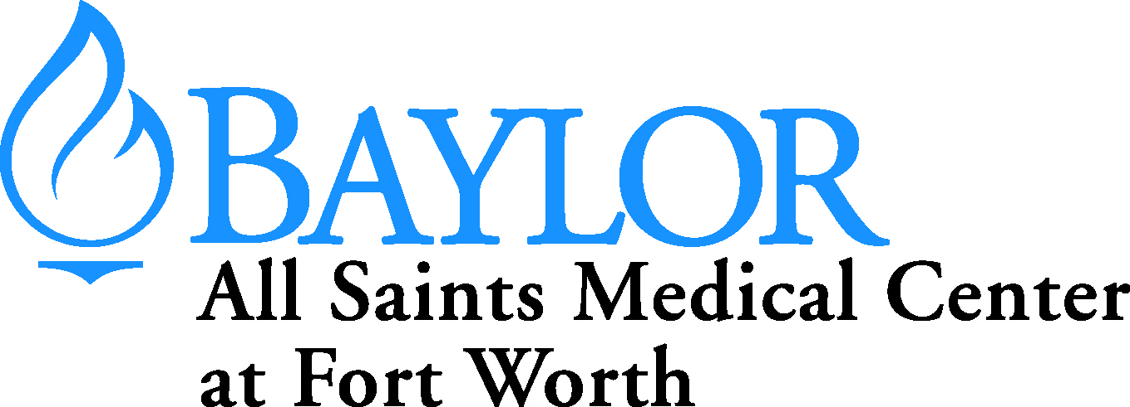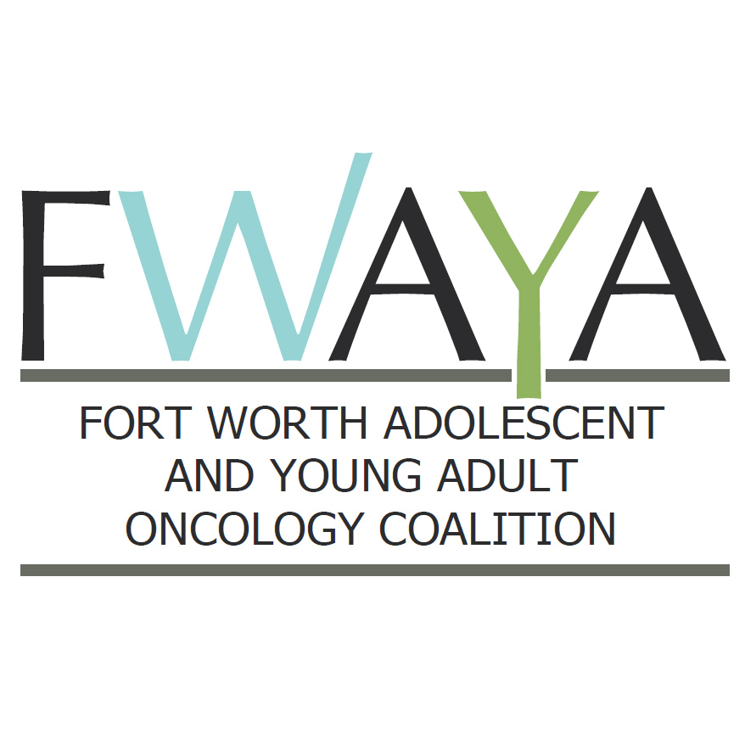

| **Projects** | **Needs** | **Questions?** |
| --- | --- | --- |
| **Project**: Identify young cancer survivors in Ft. Worth to serve as a group of ambassadors | Find out their level of comfort with sharing story |  |
| Notes: |  |  |
| **Project**: Identify local celebrities and names in community to be key spokesman |  |  |
| Notes: |  |  |
| **Project**: Branding Campaign & tell story of “how” we are collaborating, not just “what” we are building |  |  |
| Notes: |  |  |

**FWAYAOC**

**Implementation Projects and Needs Worksheet**

September 29, 2014

**Team Name: Marketing**

**Team Goal: The Marketing Team will promote Unit in the communities served by Hospital and Coalition.**