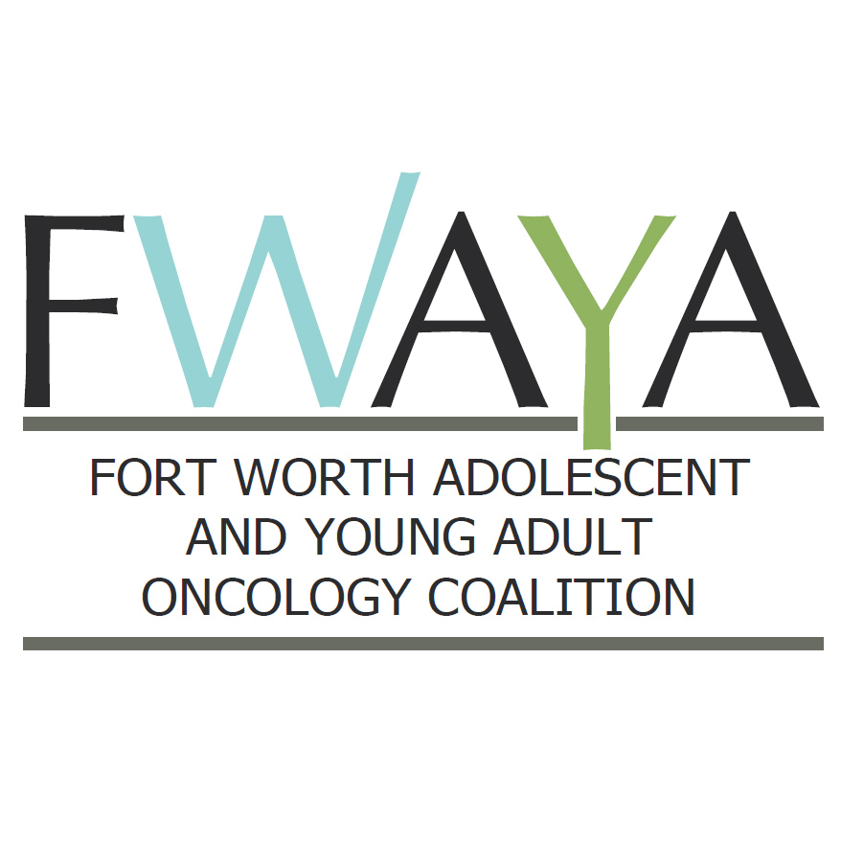

| **Projects** | **Needs** | **Questions?** |
| --- | --- | --- |
| **Project**: Connecting/Technology | Advisory Group for this  Baylor IS Engagement |  |
| Notes: |  |  |
| **Project**: Environment (AYA Friendly) | Room Forecasting  Child Care Issues  Colors/Lights/Content |  |
| Notes: |  |  |
| **Project**: TDG/Regulatory | Bone Marrow or not? |  |
| Notes: |  |  |

**FWAYAOC**

**Implementation Projects and Needs Worksheet**

September 29, 2014

**Team Name: Facilities**

**Team Goal: The Facilities Team will address the design and build out of physical unit.**